# FAULTS AND FLOODS OF MISSOULA VALLEY

JW Sears

University of Montana

## Introduction:

Missoula Valley occupies the depressed corner of a triangular, Cenozoic graben. It is one of an en echelon series of grabens that cross the central-western Montana Rockies along the Lewis and Clark shear zone. The NW-trending Clark Fork-Ninemile fault bounds the graben on the north, and the NE-trending Mount Sentinel fault zone bounds it on the east (Fig. 1). Both fault zones experienced movement in Eocene and Miocene times, as shown by the structure and stratigraphy of the Missoula valley.

The Missoula Valley is the namesake of Glacial Lake Missoula because of its excellent lake shore lines and lake bottom sediments (Pardee, 1910).

This field guide visits several key localities to consider the evolution of the Missoula graben and Lake Missoula.

## Missoula Graben Stratigraphy:

The Missoula graben exposes thick Paleogene sediments that are overlain with angular unconformity by Neogene sediments. They are equivalent to the Renova and Sixmile Creek Formations, respectively, of SW Montana (Field et al., 1985).

### Paleogene Renova Formation equivalent:

In the Missoula graben, the Renova equivalent beds exceed 4000 feet in thickness. They are not properly named, but are equivalent to the Renova Formation of SW Montana, and I use that name in this field guide. Like the Renova, the unit overlies rhyolite flows dated at 48 Ma, and is overlain with angular unconformity by Miocene-Pliocene alluvial fans, here assigned to the Sixmile Creek Formation. No fossils have been found in the Missoula area, but a tephra bed yielded an apatite fission-track age of 39 Ma. The beds are dominantly of fluvial facies.

Lithologies include pebbly gravels with exotic clast types derived from the Bitterroot Valley and sources in central Idaho, muddy overbank swelling clays derived from volcanic ash, tephra beds, lignite beds, and granitic sands. The beds are generally poorly lithified, but some gravel is tightly cemented by hematite, opal, or carbonate. The muds are susceptible to landsliding.

Although correlative, the Missoula unit differs lithologically from the Renova of SW Montana, which is dominated by thick volcanic ash that has been diagentically degraded into swelling clay. The Renova of SW Montana is richly fossiliferous, and interbedded with dated lava flows and welded tuffs, so its age range is well established at latest Eocene to early Miocene.

### Neogene Sixmile Creek Formation equivalent:

In the Missoula graben, the Sixmile Creek Formation equivalent is dominantly a coarse-grained unit which stands in contrast to the dominantly fine-grained Renova equivalent. It is made up of alluvial fan facies that grade downslope into fluvial deposits along the axes of grabens. It is correlative and lithologically similar to the type Sixmile Creek Formation of SW Montana, so I use that formation name in this field guide. The unit is as thick as a few hundred feet in the Missoula area. Facies include well-rounded fluvial gravel and angular alluvial fan gravel. The formation overlies the Renova and older rocks on an angular unconformity marked by a red laterite soil zone of Middle Miocene age. The formation was dissected by significant erosion beginning in the Pleistocene.

In SW Montana, vertebrate fossils and volcanics date the Sixmile Creek Formation to Middle Miocene to late Pliocene age, from 16 Ma at the base to 2 Ma at the top. In SW Montana, the Sixmile Creek Formation has been heavily faulted in the border zone of the Yellowstone hotspot, but in the Missoula Valley it appears to have been relatively undisturbed by tectonics.

### Pleistocene units:

Pleistocene units in the Missoula graben include glacial lake beds, widespread alluvial fans, fluvial terraces and alluvium, alluvial fans, and landslides. Landforms include ravines, gulches, braid plains, floodplains, strandlines and narrow bedrock canyons that incise older fans and valleys,.

Lake shorelines preserved on Mount Jumbo and Mount Sentinel, along with lake-bottom sediments preserved in the valley to the west, led Pardee (1910) to recognize that the giant ice- age Lake Missoula had filled the valley.

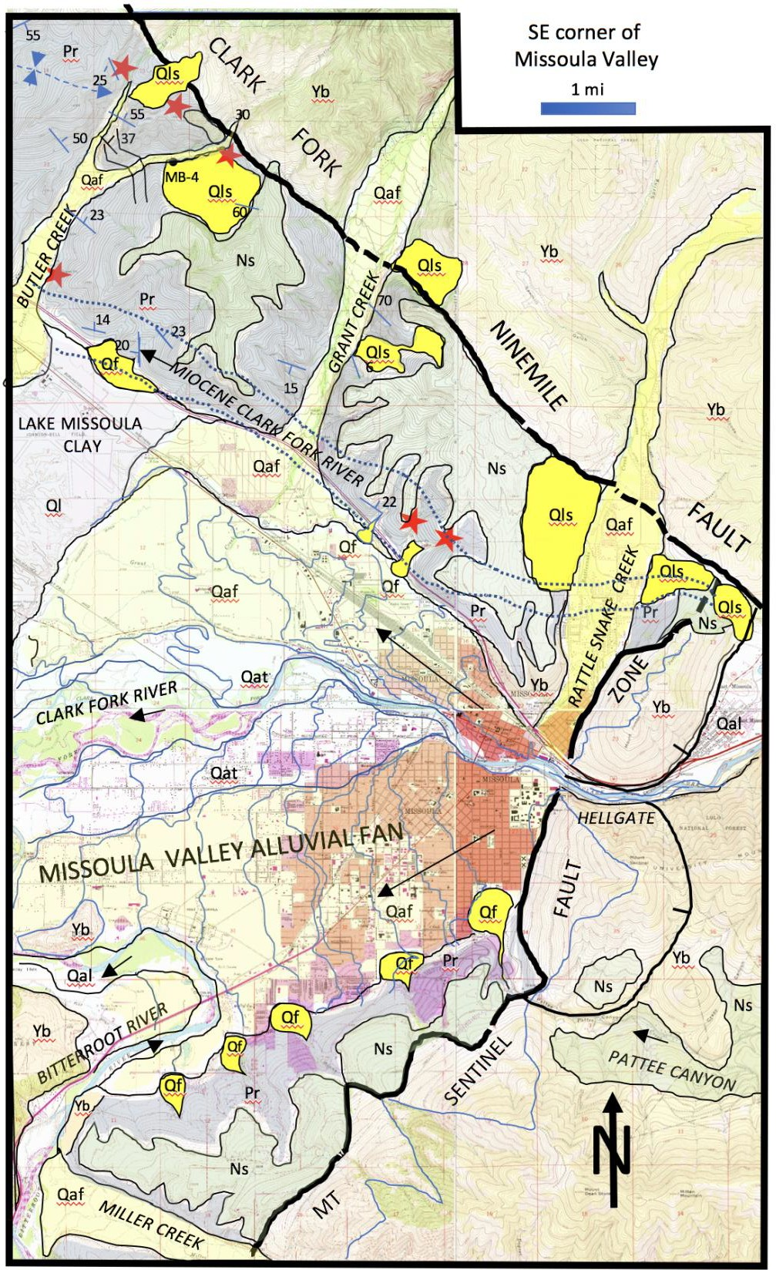

Figure 1. Geologic map of SE corner of Missoula graben.

Figure 2. Geological Map of Field Sites Discussed in the field guide.

.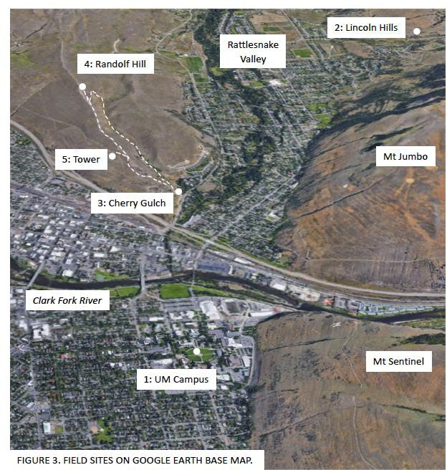

*Field Sites:*

This guide visits critical field sites around Missoula that constrain the geometry and timing of faulting, sedimentary filling, and erosional incision of the Missoula Valley graben. Field sites are numbered on Figures 2 and 3. The guide begins on the University of Montana Campus, to discuss ideas about Glacial Lake Missoula (Site 1). It then visits Rattlesnake Creek Valley and Lincoln Hills to observe red soils at the Neogene unconformity (Site 2). Next, it goes to the Cherry Gulch Trailhead (Site 3) for a hike up to Randolf Hill (Site 4). The round-trip hike covers

2.5 miles and climbs 500 feet. The hike crosses from the Belt Supergroup to unconformably overlying Eocene sediments, and summits in Miocene river gravel. Randolf Hill has a fabulous 360-degree view of the Missoula graben and its surroundings. Finally, the guide loops back to the Cherry Gulch trailhead by way of the radio tower (Site 5) to visit the Belt Supergroup/Eocene contact.

## Site 1: University of Montana Campus Oval. Lake Missoula and Mount Sentinel Fault.

### Lake Missoula:

The surface of the UM Campus Oval, at an elevation of 3200 feet, is the depositional top of a wide, late Pleistocene gravel fan that spread westward across the floor of the Missoula Valley from the mouth of Hellgate Canyon (Fig. 1). The fan is correlative with a broad, boulder-strewn gravel bed that floors Rattlesnake Valley directly across the Clark Fork River from Campus.

Alden (1953) concluded that the gravel of Rattlesnake Valley is outwash from late Pleistocene glaciers on the north flank of Stuart Peak, and is therefore about 10,000 years old. The Missoula Valley fan eroded Lake Missoula beds near the Missoula Airport, and was not covered by younger lake beds. It therefore post-dates the last filling of the lake.

Numerous building excavations around Campus and on the north side of the Clark Fork River exposed the upper 20-30 feet of the Missoula Valley fan deposit. The top few feet are dominated by fluvial channels filled with well-rounded Belt Supergroup cobbles and pebbles. Beneath that, a chaotic layer contains large angular blocks, the largest of which exceed ten feet in length. The top of one such block projects to the surface in the NW quadrant of the Oval. It has the date “1898” carved into it. Most of the blocks are dense white quartzites that resemble massive quartzite cliffs in Hellgate Canyon about a half-mile east of campus. The large blocks are scattered in a matrix of smaller angular blocks within the layer. Three-meter long blocks have been excavated from construction sites as far east as Higgins Avenue. A water main along Third Street encountered angular blocks in the layer that systematically decrease in size westward, toward Orange Street, to less than a few feet long. The layer of blocks appears to be the deposit of a massive debris flow that spread out westward from the mouth of Hellgate Canyon in the Missoula Valley fan (Alt, 2001).

The Missoula Valley fan was cut by numerous fluvial terraces that step down to the present flood plain of the Clark Fork River (Fig. 1). Enough the original depositional top of the fan is preserved to allow a reconstruction of its essential form. Figure 1 traces preserved topographic contours of the surface. The top of the fan descends smoothly westward from 3200 feet at the UM Campus to 3100 feet eight miles to the west, near the confluence of the Bitterroot River. As the fan slopes down to the west by 100 feet, the river drops by only 75 feet. The contours arc from a scarp along the base of the North Hills to a scarp along the base of the South Hills. The fan carved a 45-foot scarp in the lake-floor sediments of Lake Missoula near the Missoula Airport. (The airport was constructed the lake-bottom sediments.)

The Missoula Valley alluvial fan includes the highly productive gravel of the Missoula aquifer. Well logs across the valley show that the fan is about 200 feet thick and has three stratigraphic units – an upper bouldery gravel (including the large blocks), a middle clay-rich layer, and a lower gravel (Morgan, 1986). The fan gravels unconformably overlie Renova Formation sediments, indicating that Lake Missoula beds were scoured out before deposition of the fan.

I postulate that the Missoula Valley alluvial fan is the deposit of the final catastrophic draining of Glacial Lake Missoula. As the waters drained through Hellgate Canyon, they scalloped the quartzite cliffs on the south side of the river, eroding the quartzite blocks found in the fan deposit on campus. In the valley, the current scooped a 200-foot deep scour pit in the soft lake-floor sediment and underlying Renova Formation. The scour reached from the North Hills to the South Hills. The subsiding current then aggraded the Missoula alluvial fan sediments in the scour pit. Over time, the Clark Fork River eroded a series of river terraces through the fan deposit, down to the level of the present floodplain.

### Mount Sentinel Fault Zone:

The west face of Mount Sentinel (Fig. 4) is unusually smooth and planar from its base at 3200 feet to about 4200 feet elevation (about the level of the fire road above the “M”). Above that elevation, there are three broad valleys covered with thick forests. What did these hanging valleys lead to? South of Pattee Canyon, Mount Dean Stone has similar broad valleys above 4200 feet (Fig. 1). These lead down to alluvial fan surfaces that slope toward the bottom of the Missoula Valley. The alluvial fans are assigned to the Six Mile Creek Formation of Late Miocene and Pliocene age, and were deposited under an arid climate (Thompson et al., 1984). The fans onlap the Belt Supergroup in the footwall of the Mount Sentinel fault zone, and spread across tilted Paleogene sediments of the hanging wall, equivalent to the Renova Formation. The fans are about 200 feet thick and comprise angular and poorly sorted gravel derived from the neighboring footwall. Pattee Canyon is a long hanging valley that crosses the footwall of the fault zone, and preserves a thick section of Sixmile Creek Formation between the elevations of 3600 and 4400 feet. It is generally concordant with the alluvial fans and likely flowed into the graben, across the fault zone, as a major point source of sediment. The Miocene floor of Pattee Canyon was incised by Pleistocene erosion down to the level of the floor of the Missoula Valley. It built a fan out onto the surface of the Missoula Valley alluvial fan.

Similar hanging valleys appear to be present in the south wall of Hellgate Canyon, down to the same elevations as the ones along the west face of Mount Sentinel. That indicates that Hellgate Canyon was present in Middle Miocene, and was deepened by Pleistocene incision, similar to the incision of Pattee Canyon.

Several springs occur at the base of the alluvial fan deposits at the permeability barrier between the gravelly Six Mile Creek Formation above and the clay-rich Renova Formation below (Harris, 1997). One large spring occurs in a deep gulch near High Park in the South Hills, accessible from Parkview Way on a public trail. That spring seeps out of the Sixmile/Renova contact zone, fills a pond, and has a significant flow down a tree-lined gulch. Other springs occur in the North Hills above the 1890’s Moon-Randolf Homestead. These provided water sources for domestic use and livestock. Landslides are common in Renova mudstones where they are saturated by springs or seeps from the base of the Sixmile Creek Formation (Harris, 1997).

There is commonly a break in slope at the Sixmile/Renova contact, with the gravelly Sixmile Creek Formation forming a rim above the slope-forming Renova Formation. Combined with the red soil outcrops, springs, and common Renova landslides, the topographic profile helps in mapping the contact.

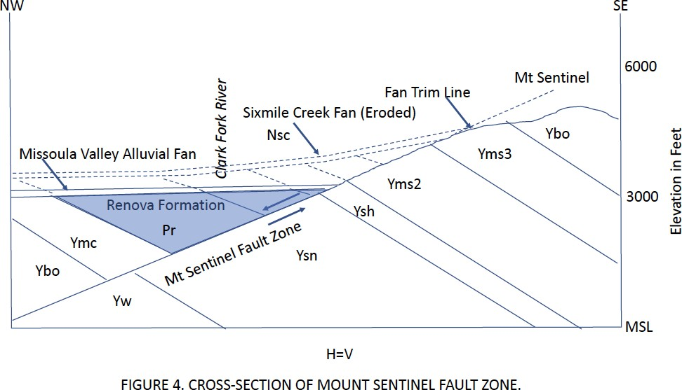

At Campus, the fans and underlying Renova Formation were completely removed by Pleistocene erosion, revealing the NW-dipping surface of the Mount Sentinel fault plane (Fig. 4). A trim line at the 4200-foot contour marks the erosional level of the valley during deposition of the Sixmile Creek Formation from 16 to 2 million years ago. Below the trim line, the fault plane was buried by the Renova Formation, which was tilted toward the fault. An unknown amount of Renova Formation was eroded prior to deposition of the Sixmile Creek Formation. As the Sixmile alluvial alluvial fans aggraded, the footwall eroded back, broadening the hanging valleys.

Pleistocene erosion incised the alluvial fans, cutting down into the underlying Renova. On Campus, erosion stripped away all of the alluvial fans as well as the underlying Renova Formation, down to 3200 feet elevation.

That erosion took place before the incision of the Lake Missoula shorelines across the west face of Mount Sentinel, but after deposition of the Sixmile Creek fans, probably during many previous episodes of filling and draining of Lake Missoula.

Mount Jumbo and Mount Sentinel may be horst blocks that collapsed into the Missoula graben in Middle Miocene time before being crossed by drainages through the Mount Jumbo saddle, Hellgate Canyon, and Pattee Canyon.

## Site 2: Lincoln Hills. Red soil zone at base of Sixmile Creek Formation.

Directions: Take Van Buren Street north from I-90 for 2 miles, to the turnoff to Lincoln Hills. Turn right on Lincoln Hills Drive and proceed for about 1.5 miles, to the Mount Jumbo Trailhead parking area (Fig. 5).

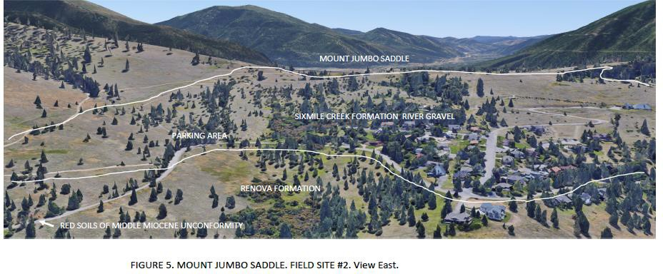

The parking area is in the basal Sixmile Creek Formation, which is here characterized by well- rounded river cobbles and boulders. The cobbles are dominated by Belt Supergroup quartzites, but careful examination also reveals fine-grained, cross-bedded, white quartzite cobbles ornamented with small pits, characteristic of quartzites in Devonian Maywood Formation channels found in the Cramer Creek area, 20 miles to the east. This indicates that the river gravel deposit flowed to the saddle in Mount Jumbo from the east. The base of the Sixmile Creek river gravel exposed here is nearly 500 feet above the modern Clark Fork River channel.

Mount Jumbo is a Missoula City Park with many hiking trails. These are closed during much of the year because an elk herd shelters here in the fall and winter and calves in the spring. The area is mostly covered by soil and vegetation, but the trails commonly show traces of well-rounded river pebbles, cobbles, and pea-gravel. The saddle in Mount Jumbo appears to be the channel of a west-flowing river that aggraded some 200 feet of river gravel. The north boundary of the saddle is the Clark Fork-Ninemile fault zone. A road-cut in the Clark Fork Valley one mile to the east exposes a 1000-foot wide zone of pulverized rock along the fault zone.

At this site, the Sixmile Creek river gravel overlies an angular unconformity that cuts across tilted and faulted Renova Formation and Belt Supergroup. It onlaps the ClarkFork-Ninemile fault in the saddle. The unconformity is marked by a bright red laterite soil zone that crops out in a cut along Lincoln Hills Drive, two tenths of a mile NW of the parking area. It also occurs on the east side of the Mount Jumbo saddle beneath the Sixmile Creek gravel, in East Missoula. The red soil records the brief period of warm and wet climate of the Middle Miocene climatic optimum, around 16 million years ago. The unconformity has been mapped across the graben valleys of SW Montana and adjacent Idaho (Thompson et al., 1982). It coincided with tectonic tilting, graben formation, and drainage re-arrangement in the Basin-Range Province, and outbreak of the Yellowstone hot spot (Sears et al., 2009).

In the Missoula area, the bright red soils help to define the geometry of the sub-Sixmile Creek unconformity in the poorly exposed hillsides. The soils are mainly seen in road cuts and construction sites. The soils were the sources of clay for some bricks in Missoula’s early buildings. The soil zone is as much as 200 feet thick within the Renova Formation beneath the unconformity. It also affected the Belt Supergroup, notably along fault footwalls. This indicates that the faulting and tilting were of Middle Miocene age, as documented in SW Montana.

## Site 3: Cherry Gulch Trailhead. Belt Supergroup overlain by Renova and Sixmile Creek Formations.

Directions: From Site 2, return to Van Buren Street on Lincoln Hills Drive. Turn left on Van Buren Street and drive 0.8 mi south to Lolo Street. Turn right on Lolo Street and drive 0.5 mi to Duncan Drive. Turn left on Duncan Drive, and drive 0.85 mi to where Duncan Drive starts down a hill. Make a hairpin right turn and go uphill into the parking area for the Cherry Gulch Trailhead.

The guide follows the Cherry Gulch Trail along the floor of the gulch for 1.3 mi to the summit of Randolf Hill (a climb of about 500 feet). The trail begins in Pleistocene terrace gravel of Waterworks Hill, about 200 feet above the surface of the Rattlesnake Valley fan. That gravel was likely deposited in a pre-Pinedale fan at the mouth of Rattlesnake Creek.

### Belt Supergroup:

The first outcrops along the trail are thin, south-dipping beds of argillite and quartzite assigned to the Snowslip Formation, the basal unit of the Missoula Group. The Missoula Group is the uppermost unit of the Belt Supergroup and is about 15,000 feet thick. The Belt Supergroup is > 45,000 feet thick in the Missoula area. It was deposited from 1.5 Ga to 1.4 Ga in an intracontinental rift basin.

### Renova Formation:

The Renova Formation overlies the Snowslip Formation of the Belt Supergroup on an angular unconformity. The Renova is not well-exposed along the trail. It can be mapped, however, by carefully searching slope-wash soils on the hillsides for distinctive pebbles of lineated mylonitic granite derived from the Bitterroot mylonite zone, which crops out 35 miles south of Missoula along the east flank of the Bitterroot Mountains. Rare pebbles of chert-clast lith-arenite of the Copper Basin Formation of central Idaho also occur. In the Missoula area, the Sixmile Creek Formation lacks these clasts. Ghostly traces of bedding on the west slope of Cherry Gulch indicate a gentle northerly dip of the Renova, above its contact with the Snowslip Formation.

The Renova Formation is a minimum of 2300 feet thick where it was logged in exploration well MB-4 in Butler Creek, 6.6 mi NW of here (Harris, 1997). Neither the top nor the base of the Renova was encountered in the well. A 500-foot thick section of gravel that was logged in the well strikes toward this area. The gravel contained mylonite cobbles, and dipped NE, toward the Clark Fork-Ninemile fault, at 37 degrees.

*Landmark*: Trail crosses two quarter-section fences and a North Hills City Park map exhibit. The Belt/Renova contact appears to cross Cherry Gulch Trail about 300 feet north of the point where the two quarter-section fences cross.

At about 1000 feet beyond the quarter-section fence, the trail starts up Randolf Hill in a ravine. The constructed trail switch-backs away from the ravine to the south and then back to the north.

### Sixmile Creek Formation:

Where the trail returns to the ravine, take a small foot path to the right for about 100 feet. This leads to a bouldery gravel bed at the base of the Sixmile Creek Formation. The gravel bed is at approximately the same elevation as the boulder bed at the base of the Sixmile Creek Formation at Site 2. The boulders are smooth, very well rounded, and are similar in compositions to those at Site 2. This is likely part of the same river channel as at Site 2, which is visible at the Mount Jumbo saddle, two miles to the east. It may represent the Middle Miocene paleochannel of the Clark Fork River. The boulder bed ends abruptly in the ravine just to the west of here at what appears to be the channel margin, cut into the Renova Formation. The same boulder bed emerges about 500 feet farther to the west on the other side of Randolf Ridge. The boulder bed is also found about a half-mile to the NE, in line with the boulder bed at Site 2. A similar boulder bed occurs about a mile north of this location, and 100 feet higher in elevation. It may indicate that the channel shifted across the valley through time as the river gravel aggraded.

Note that the Miocene channel is nearly horizontal, overlies Renova gravels that are tilted at about 30 degrees, and has different clast sizes and provenances, indicating westward transport of the Miocene paleo Clark Fork River, rather than northerly transport of the Eocene-Oligocene paleo Bitterroot River. The paleo-Clark Fork River evidently cross-cut the paleo-Bitterroot River channel when the Missoula graben collapsed along the Clark Fork-Ninemile Fault.

From the boulder bed, return to the switch-back trail, and continue up the hill. The trail approximately follows bedding in the Renova Formation up to the ridge crest. A stratigraphic section of approximately 1000 feet of Renova Formation may be present in Cherry Gulch from the basal contact with the Snowslip Formation to the base of the Sixmile Creek Formation.

*Landmark*: Four concrete posts at trail junction on ridge crest. The posts were the footings of the locally infamous aluminum communication panel that was graced with a hand-painted ‘peace sign’. It was the image of Missoula from 1980 to 2000, when it was dismantled.

At the ridge crest, the trail joins the main trail to Randolf Hill. There are small fragments of Bitterroot mylonite pebbles in the soil. The contact with the Sixmile Creek Formation occurs up the trail to the north. Several thin beds of cobble gravel along the climb suggest aggregation of a braided river bed. The crest of Randolf Hill is Sixmile Creek gravel.

## Site 4. Randolf Hill: View of Missoula Valley.

The views from Randolf Hill highlight the story of the faults and floods of the Missoula Valley.

### VIEW SOUTHEAST (Figure 6):

To the SE, the “M” decorates the grassy slopes of the west face of Mount Sentinel. The west face of the mountain is essentially a large, somewhat eroded, faceted spur of the Mount Sentinel fault zone. The fault plane dips gently to the east, at about 25 to 30 degrees. It is bounded on the north by Hellgate Canyon and to the south by Pattee Canyon. Three broad, forested ‘hanging valleys’ (HV in Fig. 6) scallop the faceted spur, down to the elevation of about 4200 feet, where they end abruptly. Below that, the hanging valleys pass into straight and narrow ravines. To the SW of Pattee Canyon, Miocene-Pliocene Sixmile Creek Formation alluvial fans are preserved up to 4200 feet, and onlap forested valleys that are equivalent to the hanging valleys of Mount Sentinel. This shows that the hanging valleys were the headwaters of alluvial fans that formerly spread into the Missoula Valley.

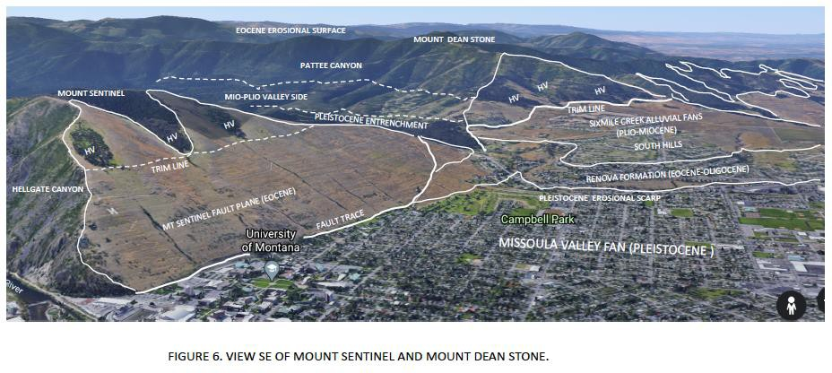

In the South Hills, the Sixmile Creek fans cover Renova Formation, which is exposed along a Pleistocene erosional scarp. The Renova was downfaulted and tilted against the Belt Supergroup on the Mount Sentinel fault plane, was deeply eroded, and then was onlapped by the Sixmile Creek alluvial fans. At Mount Sentinel, the Sixmile Creek fans and Renova Formation were stripped away by Pleistocene erosion to reveal the Mount Sentinel fault surface. The Mount Sentinel fault surface was incised by Pleistocene Hellgate Canyon. The Mio-Pliocene floor of Pattee Canyon was concordant with the 4200 foot trim line of the Sixmile Creek fans against the Mount Sentinel fault zone, and also with the saddle in Mount Jumbo. It was thus a feeder channel for alluviation of the valley. Pleistocene erosion entrenched the Mio-Pliocene valley floor of Pattee Canyon.

Glacial Lake Missoula shorelines are well displayed across the west face of Mount Sentinel. These shore lines are not deep - they were merely cut into soil zones on the fault surface. They are thought to record the last fillings and drainings of Lake Missoula. They are not expressed on the south wall of Hellgate Canyon, possibly because of talus disruption.

The floor of the Missoula Valley is a large alluvial fan that incises the South Hills. Hellgate Canyon is at the head of the fan, and the largest clasts in the fan gravels are near the canyon mouth. The fan slopes west and descends by 100 feet across 8 miles. The modern Clark Fork River incises the fan by 45 feet near the mouth of Hellgate Canyon. The fan contains the Missoula aquifer, which is recharged by the Clark Fork River.

### VIEW EAST (Figure 7):

To the east, the Mount Sentinel Fault plane makes up the steep face of Mount Jumbo. Like on Mount Sentinel, the fault plane is smooth below an elevation of about 4200 feet, and above that several hanging valleys mark the headwaters of Miocene-Pliocene fans that filled the Missoula Valley before Pleistocene erosion. Mount Jumbo saddle (Site 2) was the Miocene-Pliocene paleovalley of the Clark Fork River before it shifted to Hellgate Canyon in the Pleistocene. The Clark Fork-Ninemile Fault zone (CF-NM on Fig. 7) forms the north side of the saddle. The saddle contains well-rounded river gravel from about 3600 feet to 4200 feet elevation. It was concordant with the Sixmile Creek fans in the South Hills. Thus, the paleoriver evidently flowed through the saddle and into the aggrading valley in harmony with the deposition of the fans. The gravel rests on the bright red, Middle Miocene soil zone that was weathered in the underlying Renova Formation. The base of the Sixmile Creek Formation in the saddle is concordant with its base on Randolph Hill. A Pleistocene erosional scarp along Rattlesnake Creek exposed the Sixmile Creek and underlying Renova Formations.

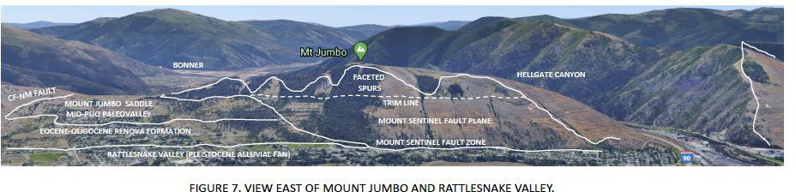

### VIEW NORTH (Figure 8):

The view north shows the high footwall block of the Clark Fork-Ninemile fault, rising to 8500 feet elevation in the Jocko Mountains, nearly 5000 feet above the Clark Fork River (Fig. 8). The footwall block exposed in this view is mostly made up of Piegan and Missoula Groups, the highest two divisions of the Belt Supergroup. The hanging wall is mostly Renova and Sixmile Creek Formations. The Renova Formation is likely > 4000 feet thick, so that the vertical offset of the Clark Fork-Ninemile fault is likely > 9000 feet. The fault line follows a break in slope near the lower tree line. Trees prefer the bedrock of the footwall to the sediments of the hangingwall. As in the other views (Fig. 5 and 6), alluvial fans of the Miocene-Pliocene Sixmile Creek Formation onlap the fault zone. The fans grade southward into the fluvial gravels of Randolf Hill. The Sixmile Creek Formation overlies the angular unconformity on the tilted and faulted Renova Formation. Likely half of the displacement took place in the Eocene-Oligocene during deposition of the Renova, and the other half took place in the Middle Miocene, before deposition of the Sixmile Creek Formation.

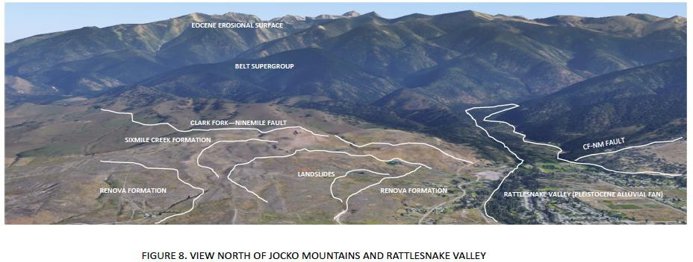

A large area on the west side of Rattlesnake Valley is marked by landslides, where the Renova mudstones gave way beneath the Sixmile Creek Formation and slid toward Rattlesnake Creek. The scarps of the landslides cut the Sixmile gravels but the sliding surfaces were within the Renova. There are several such landslides in similar settings along the trend of the Clark Fork- Ninemile fault (Fig. 1). Note that the landslides have no shorelines preserved, compared with other nearby surfaces. This tells that the landslides post-dated the last filling of Glacial Lake Missoula. It is possible that draining of the lake precipitated the collapse of the landslides.

Rattlesnake Valley emerges from a bedrock canyon as it crosses the Clark Fork-Ninemile fault. In the foreground, the valley is underlain by a bouldery Pleistocene alluvial fan. This surface is concordant with the UM Campus oval surface at the top of the Missoula Valley alluvial fan. They both may reflect the final draining of Glacial Lake Missoula.

### VIEW WEST (Figure 9):

This view is along the Clark Fork-Ninemile fault toward Ninemile Valley and Siegel Pass (on the horizon). The ridge to the SW of Siegel Pass is a tilted fault-block that clearly slopes toward the fault zone, which trends through the pass. The surface of the ridge is the Eocene erosional surface. Eocene volcanics dated at 48 million years overlie the surface as it descends into Ninemile Valley. The hanging wall exposes the top of the Missoula Group and overlying Cambrian strata near the mouth of Ninemile Creek. The adjacent footwall exposes the base of the Missoula Group, so that the fault there has a minimum of 15,000 feet of vertical stratigraphic displacement.

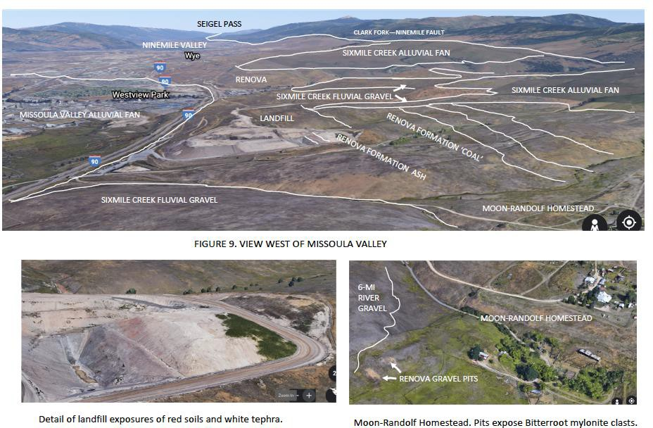

In the foreground we see a large landfill excavated in the Renova Formation. The tight clay-rich layers isolate the landfill from the Missoula aquifer. The landfill pit exposes gently NE-dipping beds of the Renova that include a red-weathered clay-rich unit and a white ash bed (inset, Fig. 9). The ash bed gave a fission-track age of 39 million years (Eocene). The pit exposed thick, NE- dipping gravel beds (Harris, 1997), but these are now buried to the south of the open pit. The stratigraphic section continues upward to the NE, and includes a coal bed, a lignite bed with fossil *Metasequoia*, and a second ash bed. The tilted section is overlain with angular unconformity by the Sixmile Creek Formation.

The Sixmile Creek Formation is made up of alluvial fans to the north, and fluvial gravel to the south. The fluvial gravel makes flat terraces and shows the trend of the Clark Fork paleovalley.

The Missoula Valley floor south of I-90 is the surface of the large alluvial fan that spread westward from the mouth of Hellgate Canyon, possibly during the final draining of Glacial Lake Missoula.

If you hike over the peak of Randolf Hill for about 500 feet, you may see two small gravel pits on the side of the hill (inset, Fig. 9). These expose gravel of the Renova Formation which contains pebbles of Bitterroot mylonite. The Renova gravel is overlain by the Sixmile Creek river gravel on the ridge top.

### VIEW SOUTH (Figure 10):

This view highlights the Pleistocene Missoula Valley alluvial fan in the foreground, cut into the Renova Formation of the South Hills in the middle ground. On the horizon is the Bitterroot Mountains metamorphic core complex. Lolo Peak is made up of metamorphosed Prichard Formation in the upper sillimanite-migmatite zone. The Bitterroot mylonite zone forms the sloping surface on the east side of the Bitterroot Mountains. It was exhumed by crustal extension in Middle to Late Eocene time, coincident with the collapse of the Missoula graben along the Mount Sentinel and Clark Fork-Ninemile fault zones.

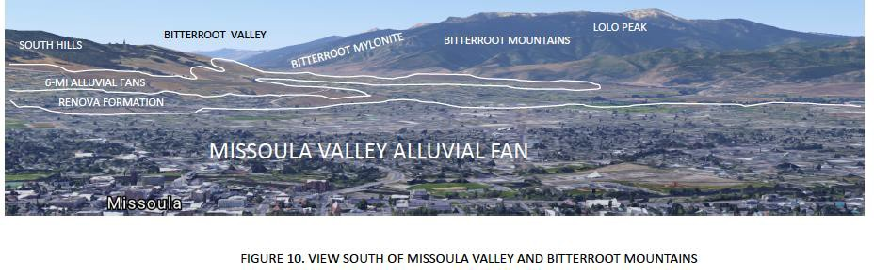

## Site 5: Radio tower. Renova/Snowslip contact.

On the hike back down to the Cherry Gulch trailhead, take the trail along the ridge crest past the tall radio tower. From the ‘Peace Sign’ site down to the tall radio tower, the path is in Renova river pea-gravel. Take the branch trail to the right just past the tall tower for about 300 yards to a small outcrop of Snowslip Formation. The beds dip about 25 degrees toward the SE. This is the near the basal contact of the Renova, where it rests directly on the Snowslip Formation. Map interpretation from here to LaValle Creek suggests that the Renova may be as thick as 4000 feet along the north edge of the Missoula graben.

Return to the main trail and proceed downhill, past the water works, to the trailhead parking area.

# END OF FIELD GUIDE

## REFERENCES CITED:

Alden, W.C., 1953, Glacial Geology of western Montana and adjacent areas: USGS PP 231, 210 p.

Alt, D., 2001, Glacial Lake Missoula and its humongous floods: Mountains Press, 208 p.

Fields, R.W., Rasmussen, D.L., Nichols, R., and Tabrum, A.R., 1985, Cenozoic rocks of the intermontane basins of western Montana and eastern Idaho, *in* Flores R.M., and Kaplan, S.S., eds., Cenozoic paleogeography of the west-central United States: Denver, Colorado, Rocky Mountain Section of the Society of Economic Paleontologists and Mineralogists, p. 9–36.

Harris, W.J., 1997, Defining benefit and hazard: distribution of upper and lower Tertiary units on the northeast flank of the Missoula Valley, Montana, UM MS thesis, 127 p.

Pardee, J.T., 1910, The Glacial Lake Missoula: Journal of Geology, v. 18, p. 376-386.

Sears, J.W., MacDonald, C., and Lonn, J., 2010, Lewis and Clark Line, Montana: Tectonic evolution of a crustal-scale flower structure in the Rocky Mountains, in Morgan, L.A., and Quane, S.L., eds., Through the generations: Geologic and anthropogenic field excursions in the Rocky Mountains from modern to ancient: Geological Society of America, Field Guide 18, p. 1- 20.

Sears, J.W., 2007, Belt-Purcell basin: Keystone of the Rocky Mountain fold-and-thrust belt, United States and Canada, in Sears, J.W., Harms. T.A., and Evenchick, C.A., eds., Whence the Mountains? Inquiries into the Evolution of Orogenic Systems: A Volume in Honor of Raymond

A. Price: GSA Special Paper 433, p. 147-166.

Thompson, G.R., Fields, R.W., and Alt, D., 1982, Land-based evidence for Tertiary climatic variations: Northern Rockies: Geology, v. 10, p. 413–417.

## FIGURE CAPTIONS

Figure 1. Geologic map of Missoula Valley. Yb- Belt Supergroup. Pr-Renova Formation. Ns- Sixmile Creek Formation. Ql-Lake Missoula lake-floor sediment. Qaf-Alluvial fan. Qal- Alluvium. Qls-Landslide. Qf-fan. Blue lines in Missoula Valley floor-Ten-foot contours from USGS topographic base. Zig-zag blue lines show triangular facets of Mt Sentinel fault zone. Red stars-Ash beds in Renova Formation

Figure 2. Topographic map of Missoula Valley. Field sites discussed in guide.

Figure 3. Google Earth image of Missoula Valley. Field sites discussed in guide.

Figure 4. Geologic cross-section of Mount Sentinel Fault zone. Dashed lines indicate material eroded from hanging wall of fault. Yw-Wallace Formation. Ysn-Snowslip Formation. Ysh- Shepard Formation. Yms2-Mt Shields Formation, member 2. Yms3-Mt Shields Formation member 3. Ybo-Bonner Formation. Pr-Renova Formation (equivalent). Nsc-Sixmile Creek Formation (equivalent).

Figure 5. Google Earth image of Mount Jumbo saddle, Site # 2.

Figure 6. Google Earth SE view of Mount Sentinel Fault.

Figure 7. Google Earth east view of Mount Jumbo and Rattlesnake Valley.

Figure 8. Google Earth north view of Jocko Mountains and Clark Fork-Ninemile fault zone.

Figure 9. Google Earth west view of Missoula Valley and tilted Renova Formation bedding.

Figure 10. Google Earth south view of Missoula Valley and Bitterroot Mountains.