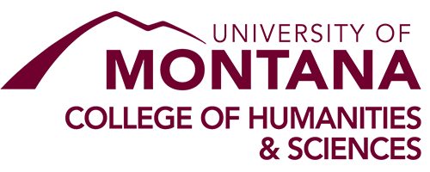
Heart and Soul Staff Excellence Award

This award recognizes staff excellence in the College of Humanities & Sciences (H&S).
The award will be presented at the H&S Dialogue on April 2.

Selection Criteria
- A state supported staff member in the H&S who has worked for the College at least one year.
- Embodies the mission and values of H& S through some of these criteria:
  - Supporting the educational mission (in any capacity)
  - Promoting diversity
  - Creating a safe, inclusive, environment
  - Demonstrating leadership qualities
  - Providing a positive attitude about work and UM
  - Taking advantage of professional development opportunities
  - Working as a team player

Nomination Form
Nominee: ________________________________________________________________________
Supervisor: _______________________________________________________________________
Job Title: _________________________________________________________________________
Department: ______________________________________________________________________
Nominator (Must be part of H&S): _____________________________________________________
Nominator role (Check one): Staff (___) Faculty (___) Student (___)
Documentation (no more than seven pages)
___ Nomination Form (this form)
___ Statement from the nominator on how the nominee embodies the criteria above
___ Letter of support from the supervisor (unless the supervisor is the nominator)
___ Optional: A letter of support from a colleague, student, or faculty member (if nominated by the supervisor, there can be two of these)

Nominations are due March 15. The required documents should be combined into a single PDF and
submitted to: http://hs.umt.edu/hs/people/staff-award.

